Who is your TA (check one)?
De Andre Corey Jingkai Neeraj

SOC 3811/5811 – STATA Assignment #3

FOR ALL STUDENTS

In this exercise, you will use data from the General Social Survey (GSS). The GSS interviews a random cross-section of about 3,000 Americans every other year. For an introduction to the GSS, go to the GSS website (here).

For this exercise, you will analyze GSS data … specifically the variables ZODIAC, WORLD6, and LIFE. We will treat WORLD6 as a continuous variable in this example. Be sure to read the on-line documentation well enough to understand what survey questions were asked to generate these variables and to ascertain value labels and missing data codes. (Note that “IAP” means “inapplicable to this person,” “DK” means “don’t know,” and “NA” means “not applicable.”)

For this exercise, I have constructed a data file (“STATA Assignment 3.dat”) that has these three variables. ZODIAC is in columns 9 through 10, WORLD6 is in column 11, and LIFE is in column 12.

Use STATA syntax files that you already have (from the first assignment, or from class examples) and modify them to accomplish the following goals. When you are done, type or paste your answers for questions #2 through #8 below into a word processor (e.g., Microsoft Word) and turn in the assignment via Canvas.

- Read the data file into STATA

See code below.

- Be sure to declare missing data codes to be missing.

See code below.

- Report the mean value of the “world is harmonious vs. world is chaotic” variable separately for people of each zodiac sign

Sign  AQUARIUS | Mean  4.03
ARIES | 3.83
CANCER | 3.63
CAPRICORN | 3.70
GEMINI | 3.71
LEO | 3.75
LIBRA | 4.13
PISCES | 3.94
SAGITTARIUS | 3.84
SCORPIO | 3.89
TAURUS | 3.81
VIRGO | 3.81

- Carry out an ANOVA test of the hypothesis that people’s views of the world as harmonious/chaotic do not vary by zodiac sign. Use significance level α=0.05.

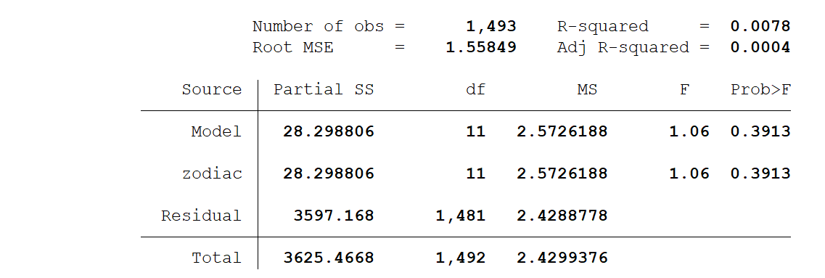

With F=1.06 we would fail to reject the null (at α=0.05) that the group means are equal across zodiac signs.

- Generate a crosstable relating zodiac sign to people’s views of whether life is exciting, routine, or dull

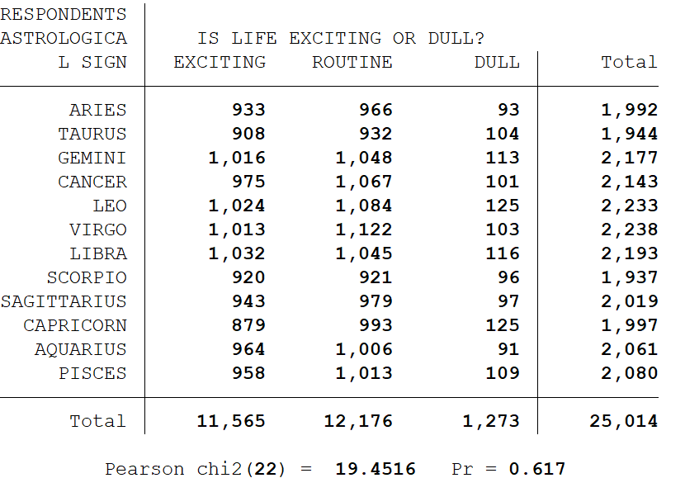
- Carry out a χ² test in order to understand whether there is a statistically significant relationship between people’s zodiac sign and their views of whether life is exciting, routine, or dull. Use significance level α=0.05.

See above. With χ²=19.4516, we would fail to reject the null at α=0.05

- Based on the results above, do people’s views of the world as harmonious vs. chaotic vary significantly by their zodiac sign?

No, we find no evidence that people views about how harmonious the world is varies by zodiac sign.

- Based on the results above, do people’s views of whether life is exciting, routine, or dull vary significantly by their zodiac sign?

No, we find no evidence that people views about how exciting the world is varies by zodiac sign.

CODE

#delimit ;
set more off;

cd "C:\Users\warre046\Dropbox\1. TO DO !\_Fall Stats Class\3 Assignments";

log using "Problem Set 6.out", replace;
log on;

infix
zodiac 9-10
world6 11-11
life 12-12
using "STATA Assignment 3.dat";

label variable zodiac "RESPONDENTS ASTROLOGICAL SIGN";
label variable world6 "WORLD IMAGE: CHAOS VS. HARMONY";
label variable life "IS LIFE EXCITING OR DULL?";

label define sign 1 ARIES 2 TAURUS 3 GEMINI 4 CANCER 5 LEO
6 VIRGO 7 LIBRA 8 SCORPIO 9 SAGITTARIUS 10 CAPRICORN
11 AQUARIUS 12 PISCES;
label values zodiac sign;
label define view 1 EXCITING 2 ROUTINE 3 DULL;
label values life view;

replace zodiac=. if zodiac >=98;
replace world6=. if world6==0 | world6>=8;
replace life=. if life==0 | life>=8;

******************************************************************************************************************;
******************************************************************************************************************;
* These commands carry out an ANOVA relating WORLD6 to ZODIAC;
******************************************************************************************************************;
******************************************************************************************************************;

sort zodiac;
by zodiac: tabstat world6, stats(mean n);

anova world6 zodiac;

******************************************************************************************************************;
******************************************************************************************************************;
* These commands carry crosstabulate LIFE and ZODIAC and produce chi-square results;
******************************************************************************************************************;
******************************************************************************************************************;

tabulate zodiac life, chi2;

log off;
log close;

